
MAKERERE UNIVERSITY
P. O. Box 7062 Kampala Uganda  E-mail: info@cis.mak.ac.ug  URL: http://www.cis.mak.ac.ug | Tel: +256-41-540628/  Fax: +256-41-540620

PROGRESS REPORT
DEVELOPING A MODULAR AND ADAPTIVE POWER ELECTRONICS SYSTEM FOR ENERGY CONSTRAINED AUTOMATIC WEATHER STATIONS
By
Tobias Newman Muhanguzi
(BTE., KyU)
2024/HD08/23083U
Supervisors
Dr. Roseline Akol
Dr. Mary Nsabagwa
12th January 2026

Executive Summary
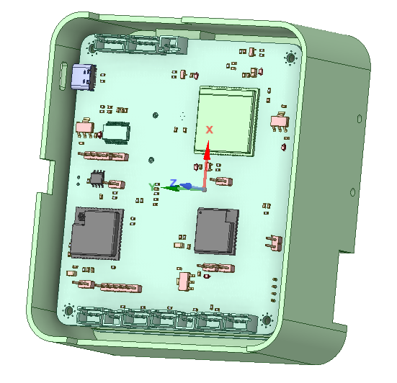
This report details tasks done from the month of October, November and December 2026. Aimed at developing two prototypes, and modifying the PCBs. These tasks lead to the completion of objective 1 of the proposal and with objective 2 under constant modification to develop the algorithm and system firmware. The system firmware has been focused mainly on power management while the communication will be assigned to an intern to work on it further. Currently, the task at hand is to test the prototype developed as I modify the PCB designs.
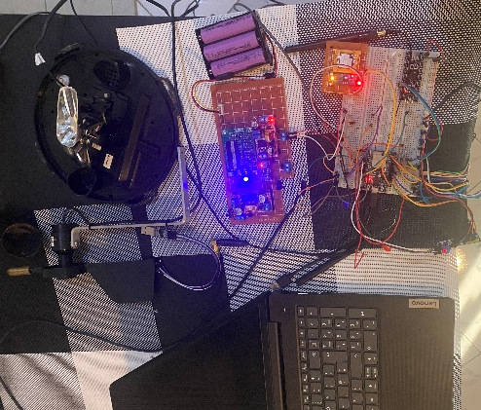  Prototype set-up | 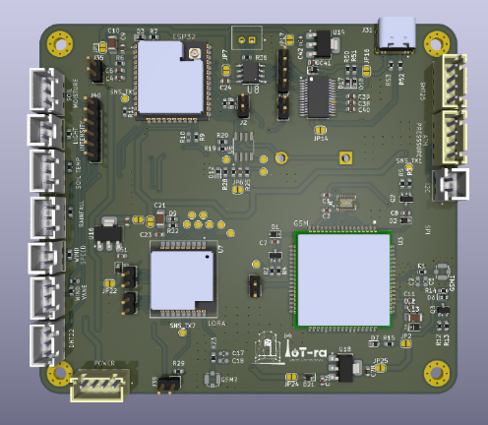  PCB design | 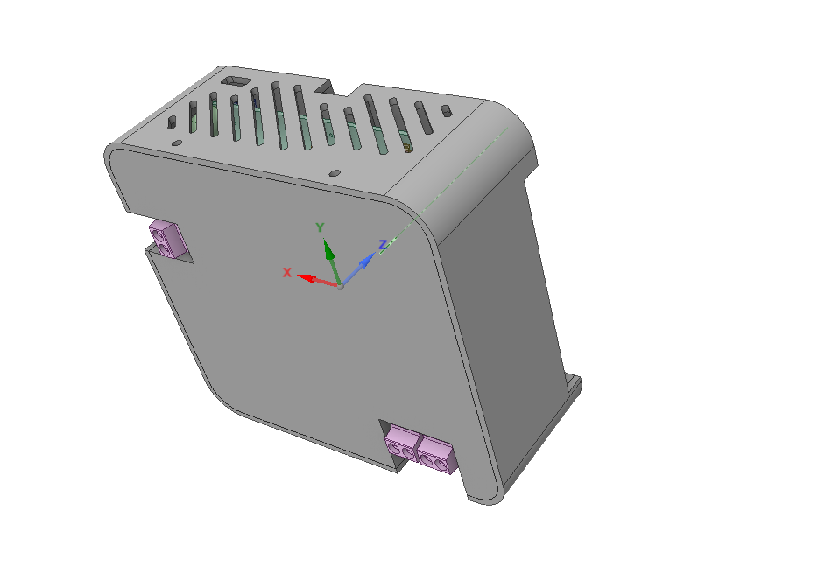  Case design
The images below show the design modifications of the system, through the three stages of Prototype development, PCB design and modification, and case design. The remaining step being frame and mounting fabrication. Prototype development involved also development of the firmware and algorithm for power management, logic and communication scheduling.

Month of October, 2025
This month focused on significant hardware revisions for the Gateway and Power boards. Key efforts included upgrading the main processing unit, integrating active power monitoring, and enhancing connectivity standards. Prototyping components have been procured to validate these designs before final PCB fabrication.

Key Accomplishments
MCU Upgrade: Replaced the main MCU with the ESP-32-WROOM-32UE to utilise an external antenna for improved range. The images below show the upgrade of the MCU on Gateway PCB.
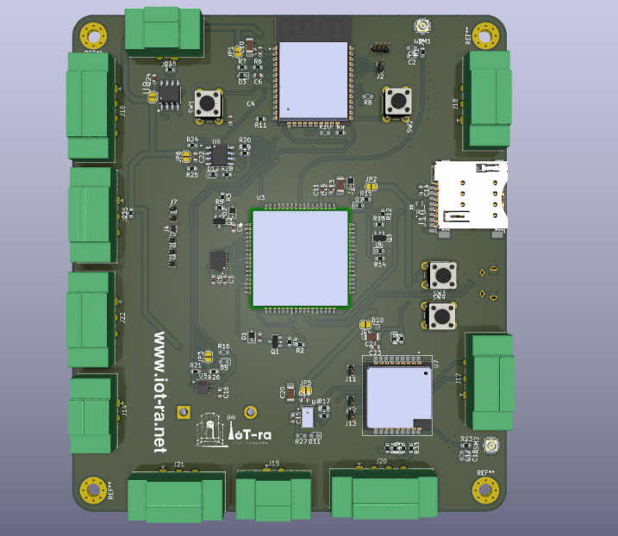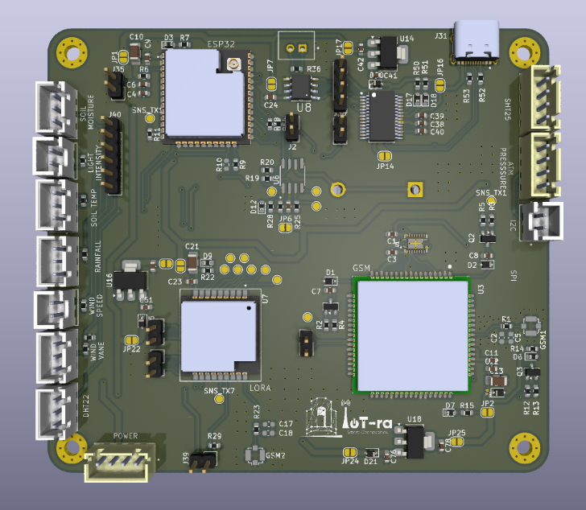
Power Board Logic: Integrated an STM32 MCU onto the power board to enable real-time active power monitoring and adjustment. The images below show the back side of the Power board with STM32
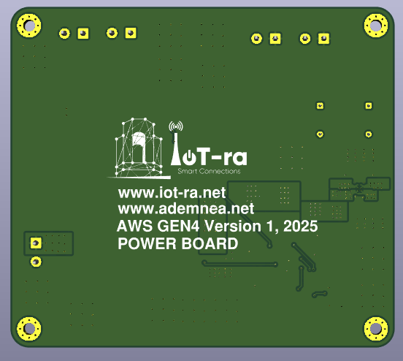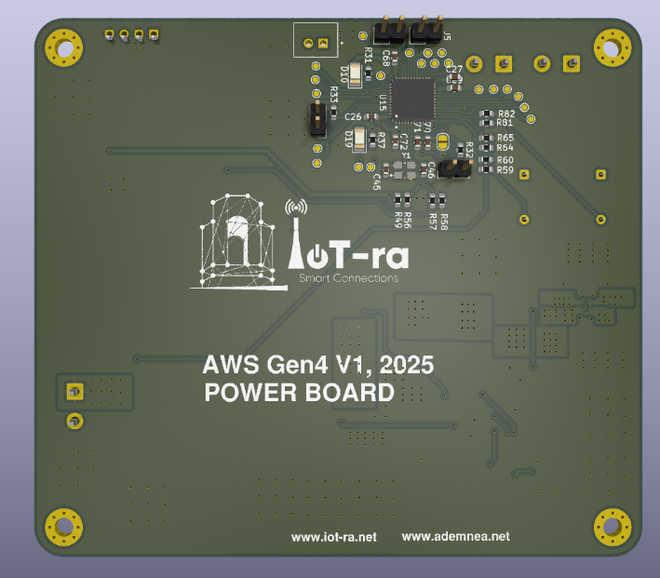
Inter-board Communication: Established SPI and I2C communication channels to facilitate data transfer between the Power and Gateway boards.
- Connectivity & Power:
  - Added an FTDI interface and USB-C port for programming and debugging.
  - Implemented basic power delivery via USB-C, including reverse current protection to prevent conflicts with external power sources.
  - Standardized connectors to the XH-A_LF_SN series for improved versatility and accessibility.
- Procurement: Purchased all necessary components to begin physical prototyping and design validation.

Pending Items & Design Considerations
UART Logic Circuit: Design a logic circuit to switch the FTDI UART connection between the Main MCU, GSM, and LoRa modules, allowing all to be programmed via the single USB-C port.
Thermal Management: Incorporate heat sink provisions in the next PCB iteration.
PCB Redesign: Finalise the PCB layout only after the prototype circuits have been proven correct to minimise fabrication errors.

Plan for the Upcoming Month
Prototyping: Assemble and test the revised circuits to confirm functionality.
Firmware Development: Develop and test code/algorithms for the new hardware configuration.
Design Refinement: Make necessary adjustments to the PCB design based on prototyping results.

Month of October, 2025
This month focused on breadboard prototyping, validating circuit connections, and writing low-level C/C++ firmware. Significant progress was made by simultaneously validating hardware, refining the schematic/PCB design, and creating modular algorithms. The Gateway board design has been optimized, and the groundwork for high-level server communication is complete.

Key Accomplishments
Hardware Validation: Successfully tested all individual subsections of the Gateway board on a breadboard to verify functionality.
Firmware Development: Developed modular C++ classes for sensor testing and communication protocols. This structure ensures easy code modification and seamless interfacing with higher-level protocols (e.g., HTTP, MQTT).
Design Refinement: Updated the general schematic by removing redundant connections found during testing.
PCB Optimization: Redesigned the PCB layout based on the refined schematic, successfully reducing the overall board footprint.

Challenges & Technical Constraints
UART Resource Conflict: The ESP32 utilizes a single extra UART port for both the GSM & LoRa modules. This requires modules to operate mutually exclusively (when one is on, the other is off).
GSM Timing Logic: The GSM module requires a specific toggle sequence and has a long setup time, making the shared-UART configuration difficult to manage. This has been identified as a software timing issue and will be resolved through code refinement.

Plan for the Upcoming Month
Power Board Integration: Shift focus to testing and validating the Power Board circuits.
Full Prototype Assembly: Move from breadboard subsections to creating a comprehensive prototype using a perforated board to validate the system as a whole

Month of December, 2025
In this month I developed two prototypes of the power system board and gateway system board, firmware development, and full system integration testing. One of the prototype is a control, upon which modifications are done to perfect the other. In turn help to modify the PCB design. Major efforts were directed towards designing and validating the Power Board, implementing power monitoring firmware on the STM32F401 and resolving communication as well as boot-related challenges on the ESP32 Gateway Board. Additionally, version control practices were established through a shared GitHub repository, and PCB designs were revisited to reflect all validated prototype changes. Overall, the month marked a transition from isolated prototyping to a more cohesive and integrated system design to improve the PCBs. The images below show the prototype, on the left is the Gateway and Right is the power and Gateway, being powered by 3 batteries with sensors connected.
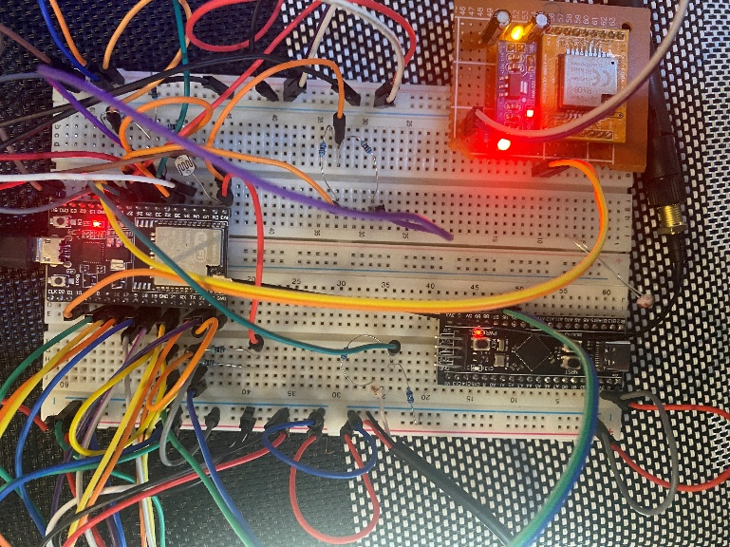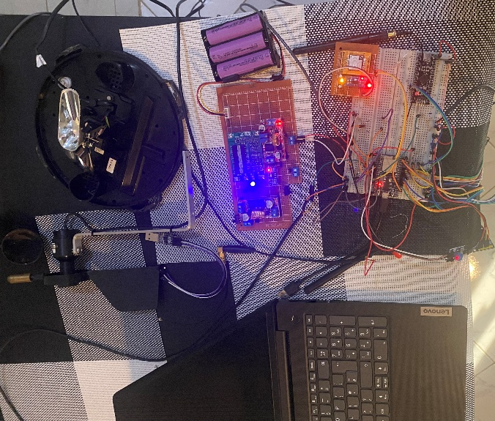

Key Accomplishments

Power Board Prototyping & Testing:
Designed and prototyped the Power Board on a perforated board. A buck converter was used in place of an MPPT controller to function as a solar charger for the battery cells. The converter was configured at a higher output voltage to ensure effective charging, and the setup was successfully tested using a solar panel.

Design Validation & PCB Creation:
Validated the Power Board design through testing and proceeded to create the corresponding PCB layout based on the confirmed prototype behavior.

Firmware Development (STM32F401):
Wrote firmware for the STM32F401 microcontroller to perform power monitoring. The firmware enables voltage level sensing and transmits the measured data to the ESP32 via I²C communication.

System Integration Testing:
Tested the complete system with the Power Board supplying power to the Gateway Board, validating stable operation across both boards under real conditions.

ESP32 UART Configuration:
Implemented a custom UART configuration for the LoRa module on the ESP32. This was done to address challenges encountered while multiplexing LoRa and GSM modules, both of which have long setup and initialization times.

ESP32 Boot Issue Resolution:
Identified boot failures caused by the use of strapping pins for peripheral connections. This issue was resolved by selecting logic-high strapping pins to avoid logic-level conflicts during ESP32 boot and reset cycles.

Sincerely,

Lt Tobias Newman Muhanguzi
MSc Student – Task 2.4, AdEMNEA Project
+256787675585‬, tn.muhanguzi@ieee.org

